

COMPLAINT

THE UNDERSIGNED COMPLAINANT/S TO THIS HONORABLE OFFICE, MOST RESPECTFULLY ALLEGE/S THAT:

1. NAME/S OF COMPLAINANT/S: AGE STATUS

Name:_Rejoice Magbutong___________ __21___ _Single__
_________________________________ _______ ________
Tel No:__09353236457______________ _______ ________
_________________________________ _______ ________
Email Add:__rmagbutong@gmail.com__ _______ ________
_________________________________ _______ ________

2. ADDRESS: _Prk. Maharlika, Cuambogan, Tagum City,______________________
_Davao del Norte____________________________

3. NAME/S OF RESPONDENT/S:

Company Name:_________________________
Tel No:________________________________
Email Add:_____________________________

4. ADDRESS: ___________________________________________________
___________________________________________________

5. OWNER/MANAGER: ________________________________________

6. CAUSE/S OF ACTION:
( ) VIOLATION OF THE CONSUMER ACT OF THE PHILIPPINES
(R.A. 7394) , MORE PARTICULARLY:

( ) PROVISIONS ON CONSUMER PRODUCT QUALITY & SAFETY
( ) PROVISION ON DECEPTIVE, UNFAIR AND UNCONSCIONABLE ACTS/PRACTICES
( ) PROVISIONS ON CONSUMER PRODUCT AND SERVICE WARRANTIES
( ) PROVISIONS ON LABELING AND FAIR PACKAGING
( ) PROVISIONS ON DEFECTIVE PRODUCTS AND SERVICE IMPERFECTION
( ) PROVISIONS ON ADVERTISING AND SALES PROMOTION
( ) CHAIN DISTRIBUTION PLANS OR PYRAMID SALES SCHEMES
( ) OTHER PROVISIONS CONTAINED THEREIN, SECIFICALLY:
__________________________________________________
__________________________________________________
__________________________________________________
__________________________________________________
( ) VIOLATION OF PHILIPPINE LEMON LAW (RA 10642 )
( ) VIOLATION OF THE BUSINESS NAME LAW
( ) VIOLATION OF THE LAW REGULATING THE BROKERAGE BUSINESS
( ) VIOLATION OF R.A. NO. 71, AS AMENDED (PRICE TAG LAW)
( ) OTHER FAIR TRADE LAWS
SPECIFY: _________________________________________
_________________________________________
_________________________________________
_________________________________________
AND/OR

(/) NARRATION:

I purchased my Poco M3 from Xiaomi LazMall Flagship Store on Lazada in May of this year and have already encountered dead boot twice! I'm a graduating student, and this has been inconvenient for me because I take my online classes on my phone. The first dead boot encounter, because I was too busy dealing with our Practicum, I'm left with no choice because I absolutely require the phone for communication and other academic reasons as I have no other device to use. I called the Xiaomi customer service number, but the line was extremely busy at the time. As a result, with no other option, I opened the back of my phone and reheated the IC with a blower, following a tutorial on YouTube and was extremely cautious, since I'm a BSIT student and have a basic understanding of the components. I succeeded, the phone turned on again.

The second dead boot, I simply let it go and planned to send it to the Service Center for a repair or request for a refund even if I’m so busy. Right now, I'm just borrowing a PC from a friend because we still have a Practicum, but it's becoming increasingly embarrassing. We also have classes in other subjects. I sometimes miss my other classes, unlike if I have a good working phone.

How many classes do I still have to miss as a result of this problem? I already emailed Xiaomi PH about this matter. I receive no response. I called their hotline again last Tuesday, November 23, 2021, and the CSR advised me to first try alternative methods to get the phone to work again, and if that does not work, I should call them again on Friday, November 26, 2021.
I need your help as soon as possible because my final defense is on December 6, 2021. I can wait, but it would be much better if it could be repaired or refunded sooner. I've read a lot of Facebook threads where people say that even though they opened their phones three or four times because they had no choice and that the Xiaomi POCO M3 is still a defective product despite consumer intervention, DTI finds a way for Xiaomi to do the repair for free or even refunds.

I’m still a student and I have no source of income, please help me that Xiaomi Service Center will repair my phone for free. I was unaware that the product was defective. I purchased it simply because it was the only phone that I could afford. Additionally, the fact that I paid for this phone with my own savings hurts me tremendously.

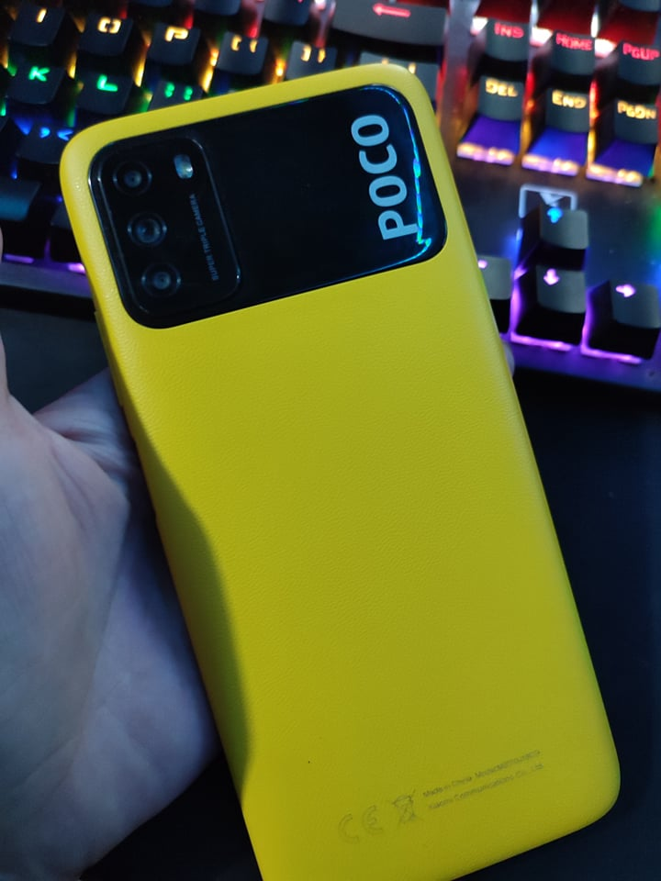
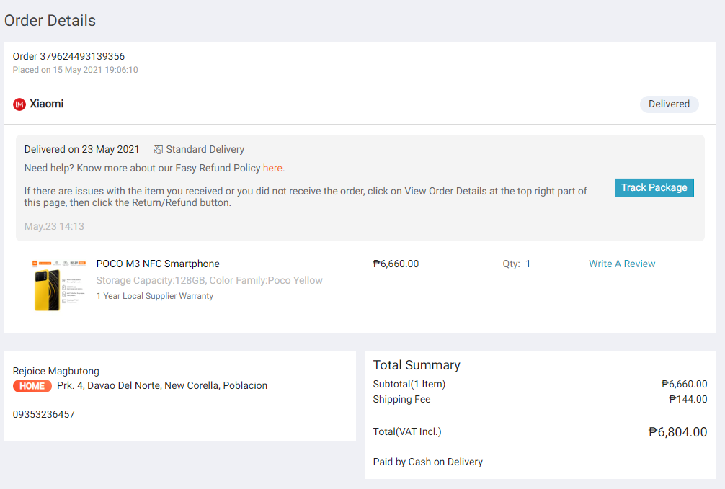
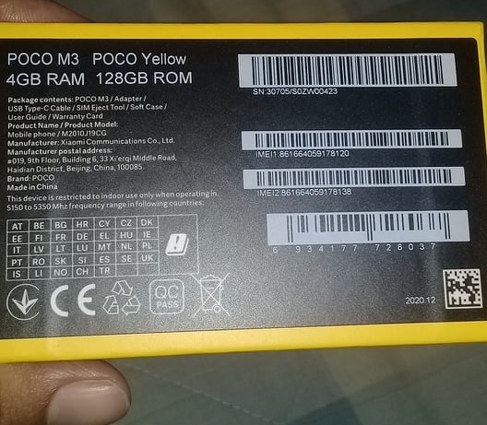
7. PROOFS/EVIDENCES (ATTACHED):
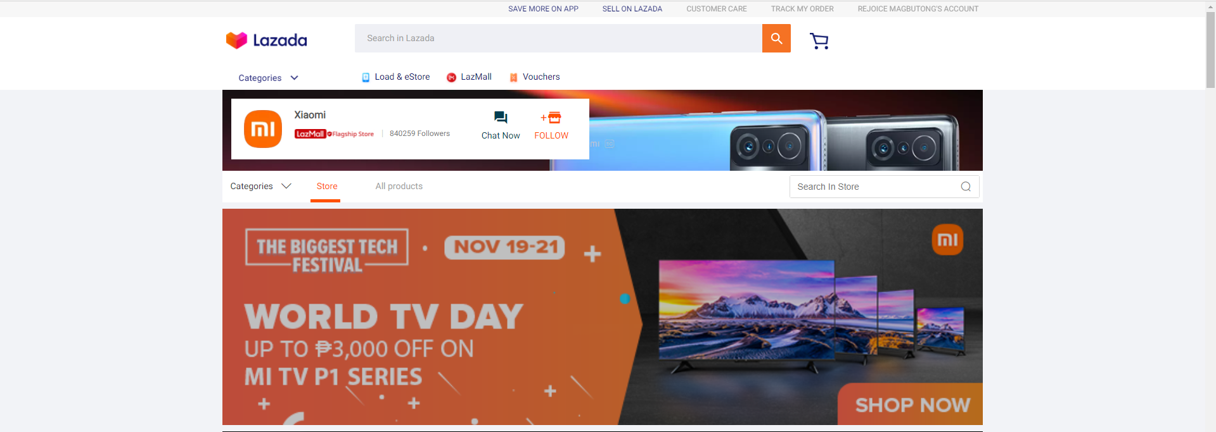

8. RELIEF: COMPLAINANT/S PRAY FOR THE FOLLOWING:

(/) REFUND
(/) REPLACEMENT
(/) OTHERS:
____Repair___________________________
____________________________________
____________________________________

IN WITNESS WHEREOF, I HAVE HERUNTO SET MY HAND THIS ____ DAY OF ___________________, 200___, IN _______________________________.
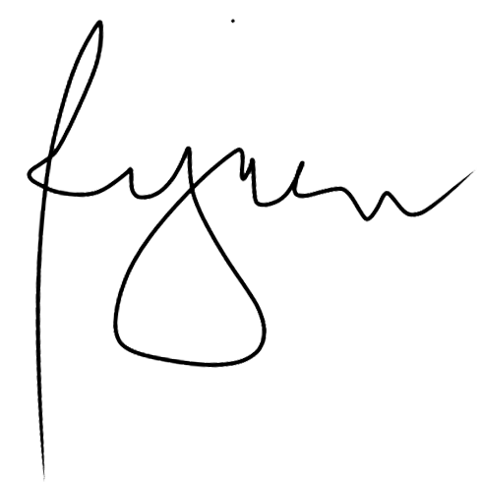

___Rejoice Magbutong____
COMPLAINANT

VERIFICATION/CERTIFICATION

THE COMPLAINANT/S, UNDER OATH, HEREBY DEPOSE/S AND SAY/S:

A) THAT HE/SHE/THEY IS/ARE THE COMPLAINANT/S IN THE INSTANT CASE:
B) THAT HE/SHE/THEY HAS/HAVE READ AND UNDERSTOOD THE CONTENTS THEREOF:
C) THAT THE ALLEGATIONS THEREIN ARE TRUE AND CORRECT OF HIS/HER/THEIR OWN PERSONAL KNOWLEDGE AND BELIEF
D) THAT FURTHER HE/SHE/THEY CERTIFY THAT AS OF THIS DATE, HE/SHE/THEY HAS/HAVE NOT FILED IN ANY COURT, TRIBUNAL, OR QUASI-JUDICIAL AGENCY, OTHER ACTION/S OR CLAIMS INVOLVING THE SAME PARTIES AND THE SAME ISSUES. SHOULD HE/SHE/THEY FIND/S THEREAFTER THAT A SIMILAR ACTION OR CLAIM IS FILED OR PENDING IN ANY OTHER COURT, TRIBUNAL, OR QUASI-JUDICIAL AGENCY, HE/SHE/THEY SHALL REPORT THE SAME WITHIN FIVE (5) DAYS THEREFROM TO THIS HONORABLE OFFICE.

_______________
COMPLAINANT

SUBSCRIBED AND SWORN TO THIS ____ DAY OF ____________, AFFAINT/S HAVING EXHIBITED TO ME HIS/HER/THEIR COMMUNITY TAX CERTIFICATE NO. ________________ ISSUED ON ___________________ AT _______________ AND HIS/HER/THEIR GOVERNMENT-ISSUED IDENTIFICATION CARD NO. _______________________, AS FOLLOWS:

NAME CTC DETAILS. I.D. DETAILS

_________________________ ____________________ __________________
_________________________ ____________________ __________________
_________________________ ____________________ __________________
_________________________ ____________________ __________________
_________________________ ____________________ __________________
_________________________ ____________________ __________________

________________________
ADJUDICATION OFFICER

